Test Case No: TC005
State/LOB: AZ/DP3
Quote Number: 1400043417
Jira Number: QAAZDP3-10044
Log in to the Claims environment and initiate a new claim by selecting FNOL (First Notice of Loss). Search for the policy using the policy number and proceed with Save & Continue. Verify that the Policy Information, Insured Details and Third-party details. Navigate through Participant List and Policy Details sections to validate the information, then complete the step by clicking Save & Continue.
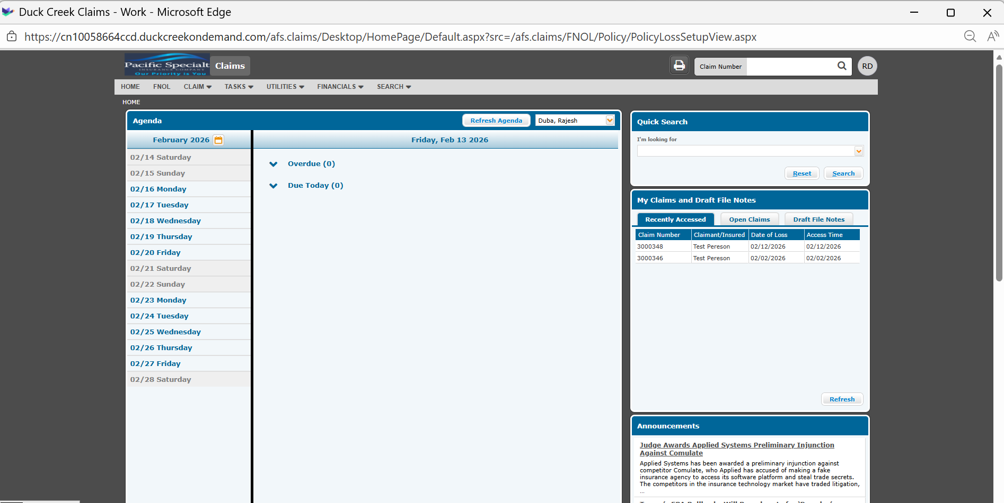
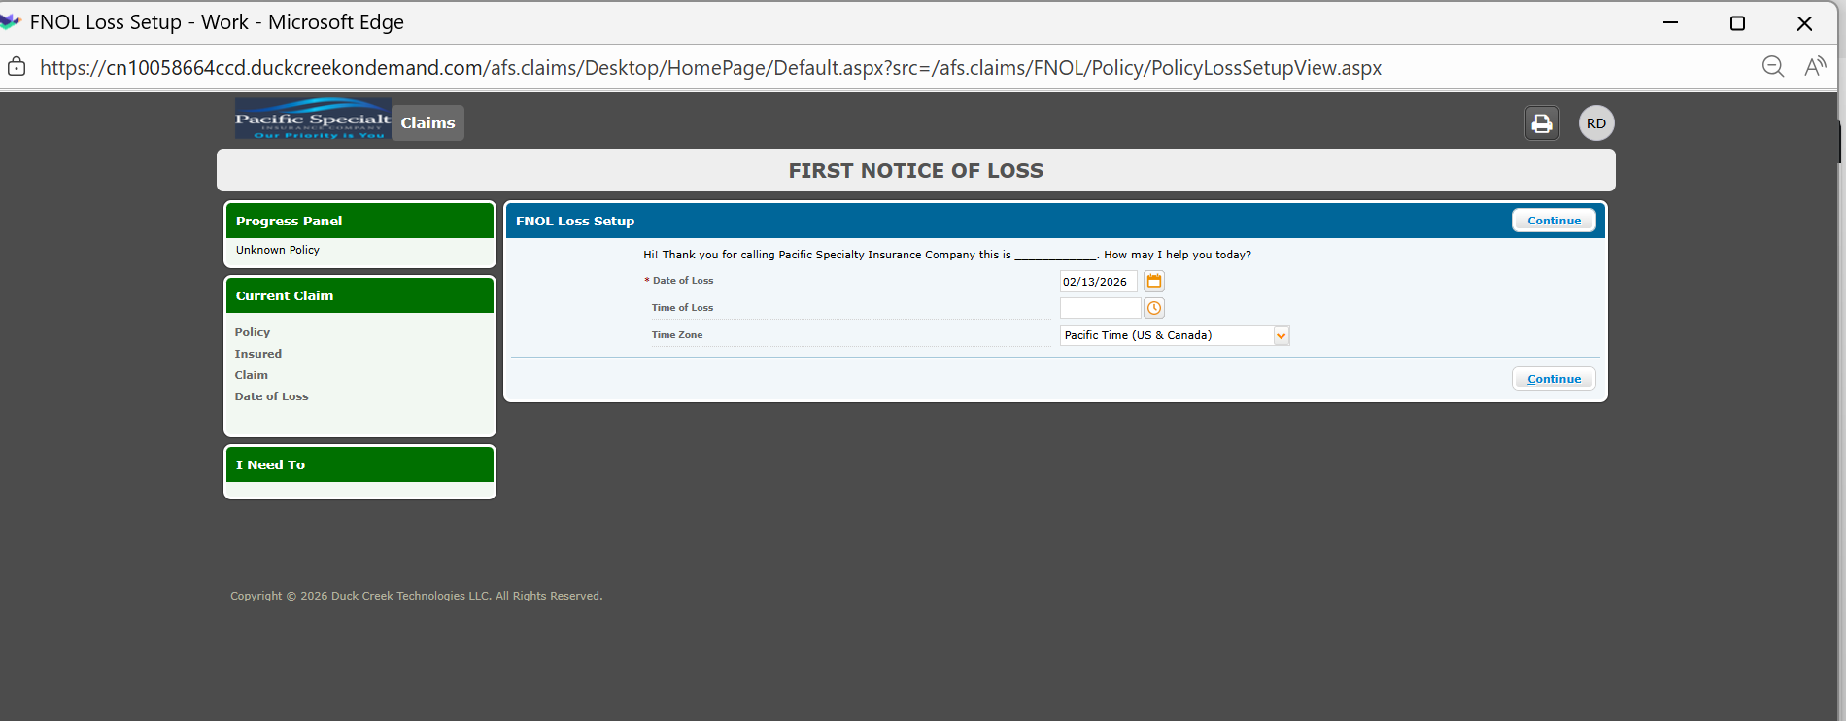
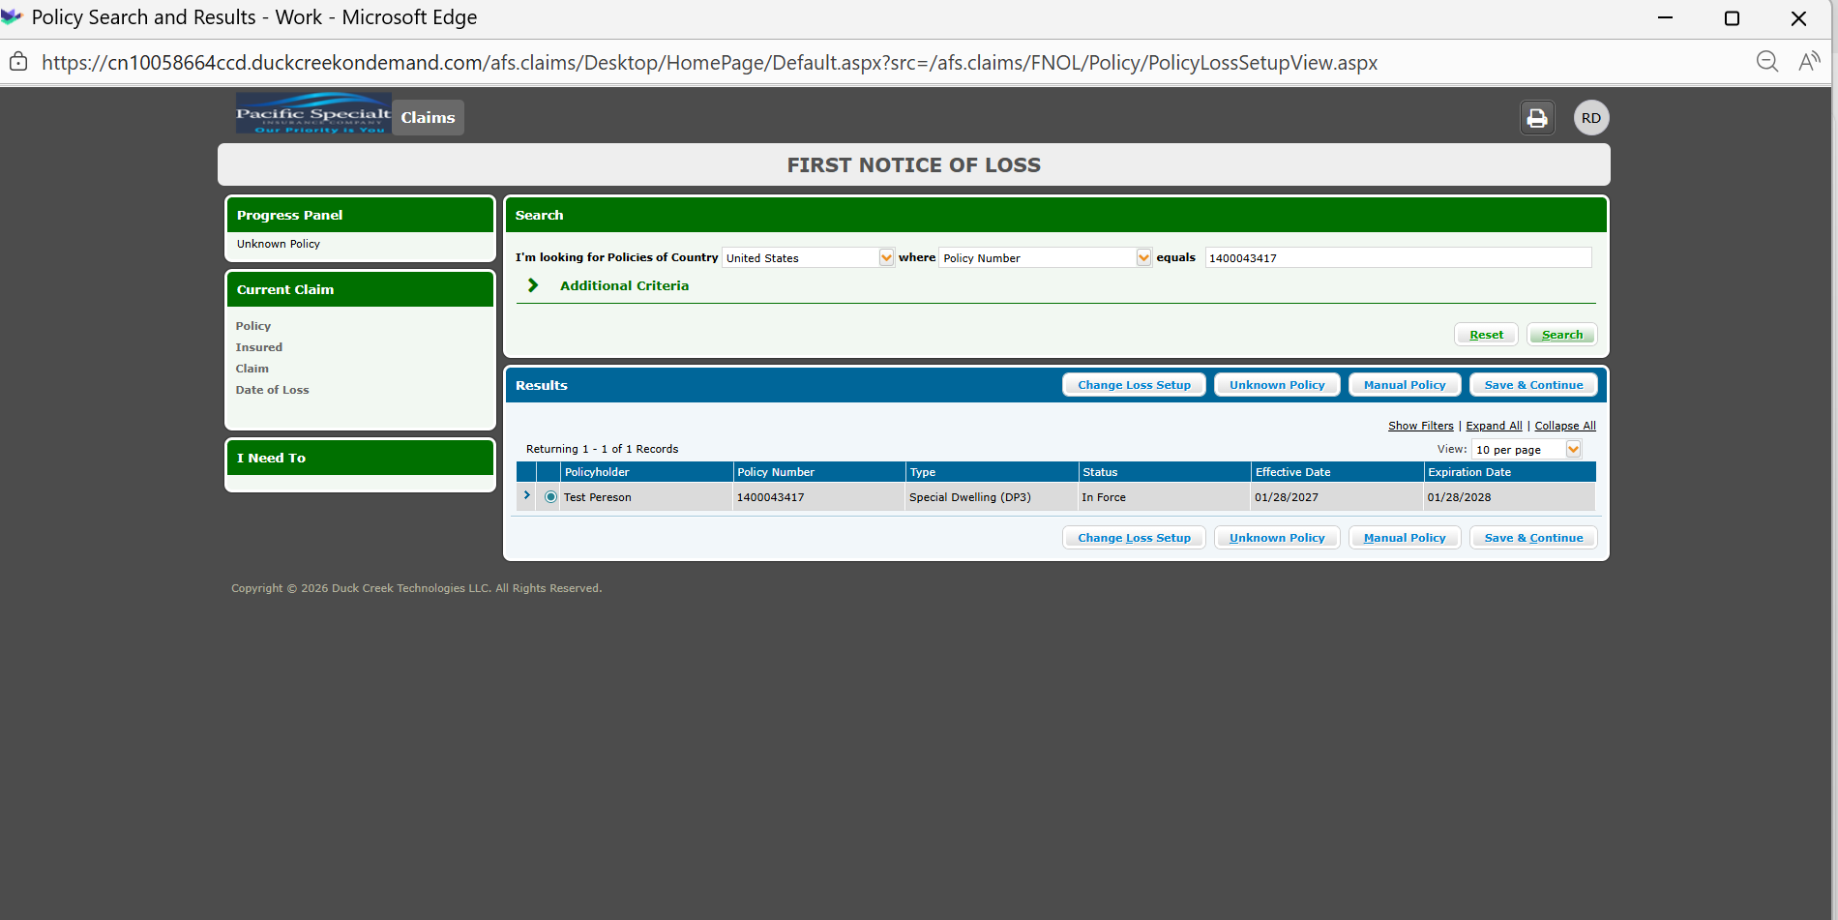
Policy Information:
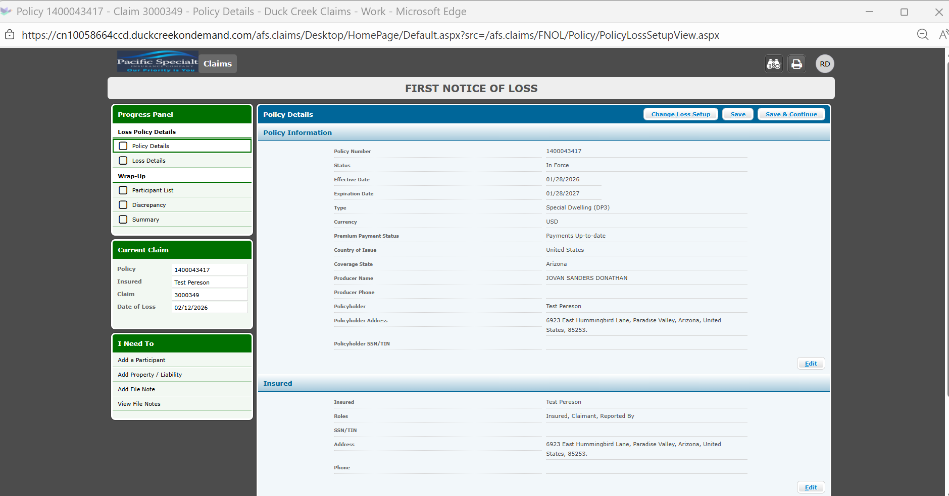
Insured Details:
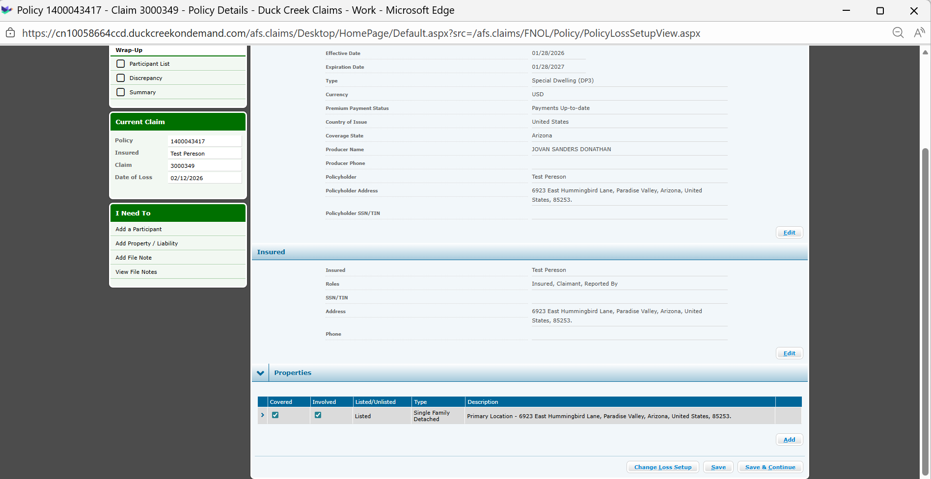
Loss Details:
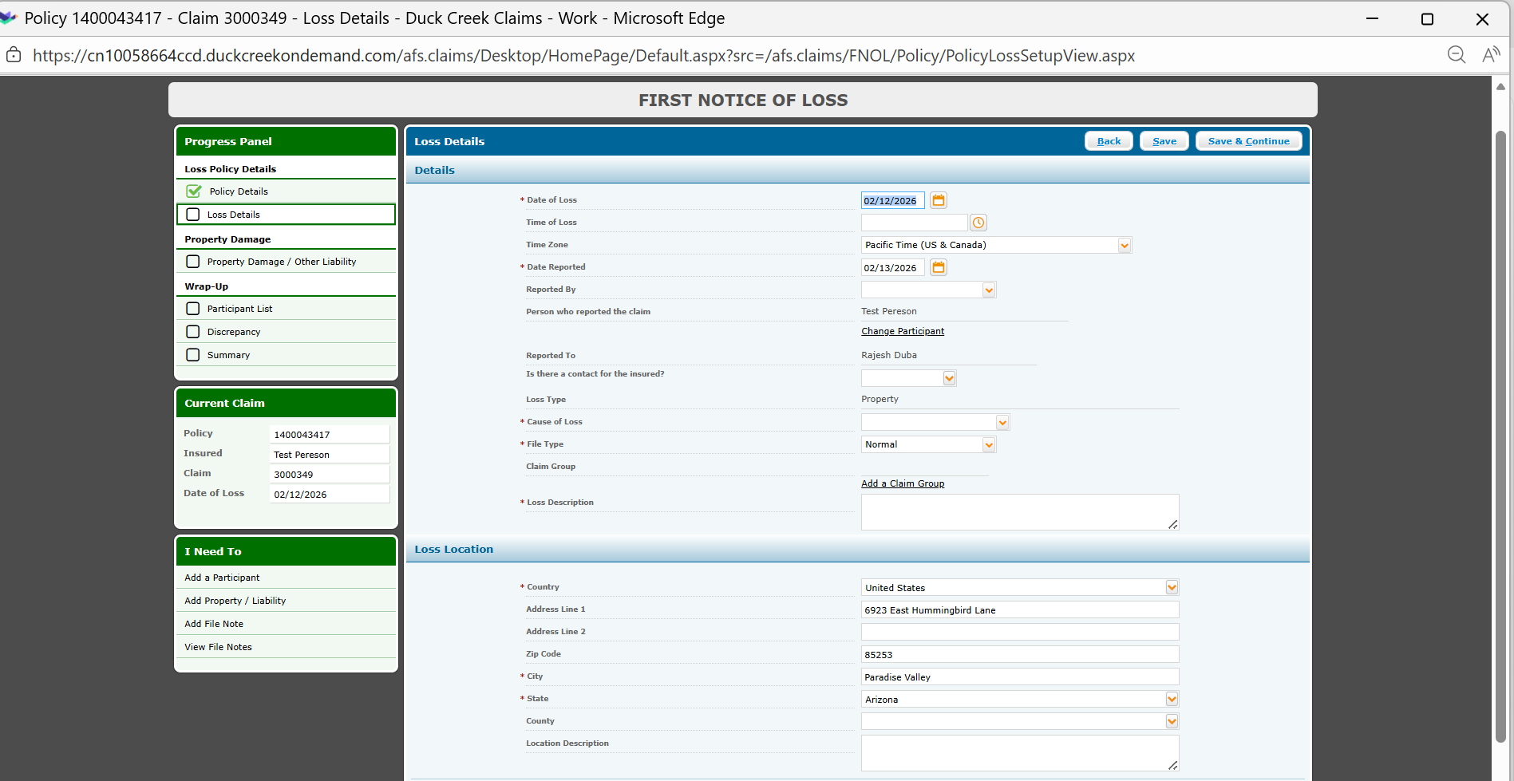
Participant details:
